Algorithm Details

Requirement: Well-explained and optimized algorithms, and include visual aids such as flowcharts or pseudo-code.
Algorithm A: Secure Role-Based Authentication (Login)
Description: This algorithm securely authenticates users and assigns a time-limited JSON Web Token (JWT). It checks the encrypted password and fetches the user's specific access level (Role) to determine which dashboard they see. Pseudo-code:
START
RECEIVE username, password from client request
IF username OR password is empty:
RETURN Error "Credentials required" (HTTP 400)

CONNECT to Database
EXECUTE SQL: Fetch UserID, PasswordHash, Role, and ProfileIDs where Username matches

IF user exists AND verify_password(password, PasswordHash) is TRUE:
CREATE payload containing: UserID, Username, Role, ProfileIDs, ExpiryTime (8 hours)
GENERATE JWT Token using SECRET_KEY and payload
EXECUTE SQL: Update LastLogin time for User
RETURN Success with JWT Token and Role (HTTP 200)
ELSE:
RETURN Error "Invalid credentials" (HTTP 401)

CLOSE Database Connection
END

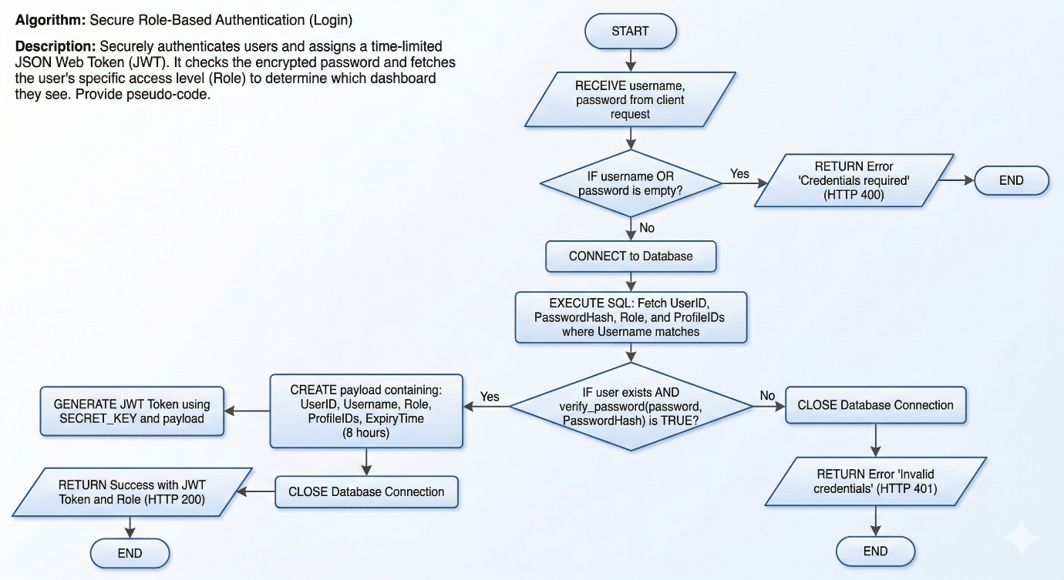

Algorithm B: Bulk Patient Data Import with Validation
Description: This algorithm allows administrators to upload an Excel or CSV file to create hundreds of patient records instantly. It optimizes database interactions by parsing the file in memory, validating each row, skipping duplicates, and rolling back if a critical failure occurs. Pseudo-code:
START
RECEIVE file upload from Admin
IF file extension is NOT .csv or .xlsx:
RETURN Error "Invalid file format"

SAVE file temporarily to "uploads/patient_imports/"
PARSE file into memory using Pandas Dataframe

INITIALIZE successful_count = 0, failed_count = 0, error_log = []

FOR EACH row IN Dataframe:
EXTRACT Name, Email, Gender, DOB, Phone, Address, BloodGroup
CHECK if Email already exists in Database

IF Email exists:
ADD "Row X: Email already exists" to error_log
INCREMENT failed_count
CONTINUE to next row

TRY:
EXECUTE SQL: INSERT row data into Patients table
INCREMENT successful_count
CATCH Error:
ADD "Row X: [Error Message]" to error_log
INCREMENT failed_count

EXECUTE SQL: INSERT summary (successful_count, failed_count, error_log) into ImportHistory
COMMIT Database Transaction
RETURN Import Summary (Total, Success, Failed, Errors)
END

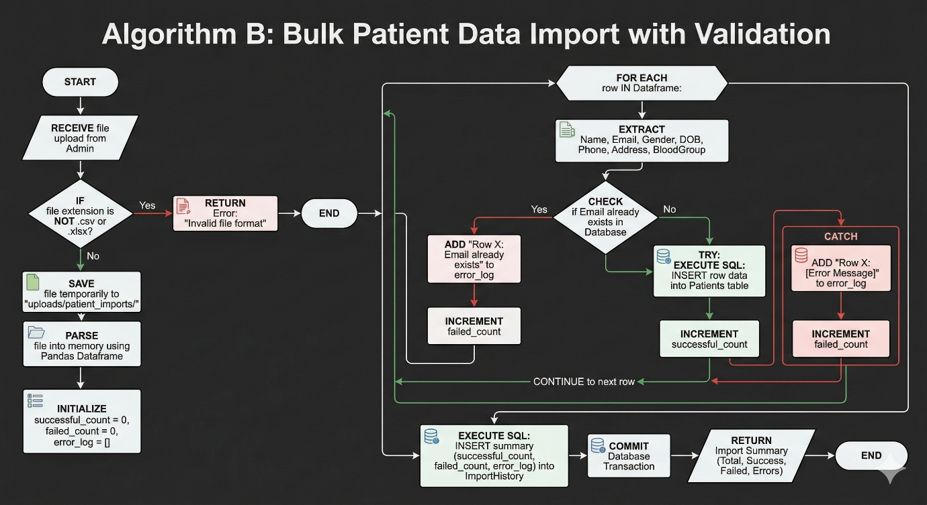

Algorithm C: Patient Summary Aggregation
Description: This algorithm fetches a comprehensive 360-degree view of a patient with a single API request. Instead of making the frontend ask the database five different times, the backend executes targeted SQL queries sequentially and aggregates the data into one clean JSON object. Pseudo-code:
START
RECEIVE patient_id from Request
VERIFY user has permission to view this patient (Admin/Doctor/Self)

INITIALIZE patient_summary_object = {}

TRY:
FETCH Demographics and Summary Notes for patient_id -> Add to object
FETCH Visit History (Join with Doctors) -> Add to object
FETCH Diagnoses History -> Add to object
FETCH Prescriptions History -> Add to object
FETCH Uploaded Medical Files/Scans -> Add to object

RETURN patient_summary_object (HTTP 200)
CATCH Error:
RETURN Error "Failed to load summary" (HTTP 500)
END

